PROJECT DESCRIPTION/SUMMARY

U.S. Army Corps of Engineers

Site Inspections

Formerly Used Defense Sites

Military Munitions Response Program

Information Sheet

Fall 2005

Introduction
The Department of Defense (DoD) is responsible for environmental restoration of properties that were formerly owned by, leased to or otherwise possessed by the United States and under the jurisdiction of the Secretary of Defense. Such properties are known as Formerly Used Defense Sites (FUDS). The Army is the executive agent for the program and the U.S. Army Corps of Engineers (USACE) is the organization that manages and directs the program's administration.
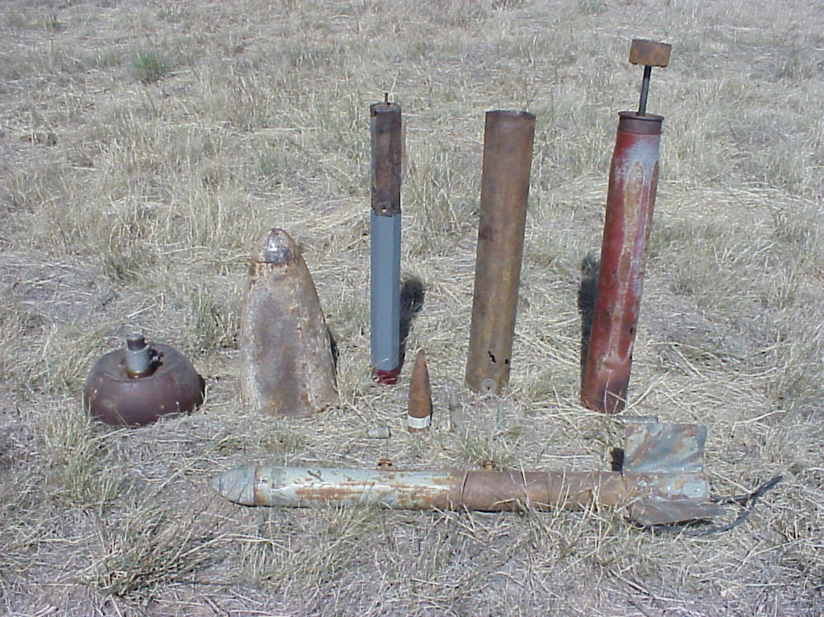
The USACE is conducting Site Inspections of FUDS to determine if any munitions and explosives of concern (MEC) or munitions constituents (MCs) are present on property formerly owned or leased by the DoD. MEC consists of unexploded ordnance, discarded military munitions, and residual bulk explosives that still pose an explosive safety hazard (see photo below for some samples of munitions). MC refers to the chemical contaminants associated with munitions items that have been released into the environment. Many of the sites visited during this project may not have been used since the World War II timeframe, or their use changed when the property was transferred to another branch of the military or other private or public landowners.
A Site Inspection is part of the Comprehensive Environmental Response, Compensation, and Liability Act (CERCLA) process. A Site Inspection is conducted to determine if there are any environmental hazards present that may pose a threat to human health and the environment. Should hazards be identified during the Site Inspection stage, the property would then continue onto a Remedial Investigation and Feasibility Study (RI/FS) to more fully characterize the hazards present and develop appropriate remedial alternatives for the site. .
Alion Science &Technology, Inc. is assisting the USACE Baltimore District in performing this evaluation at FUDS in the Northeast region. Alion and the District will review historical records and maps, meet with site regulators and key stakeholders, and conduct field inspection activities in the area(s) of interest. The outcome from these Site Inspection activities will be to determine if the project site poses any threat to human health or the environment, and if further work needs to be done either through an RI/FS or some type of removal action.
Process
Development of the Conceptual Site Model
Alion is working closely with the District to identify historical documents and information sources that would be of use during the site inspection process. Information collected from various resources may include identification of the physical environment, any potential MEC or related contaminants, and potential receptors and exposure pathways. Information gathered about the physical environment includes collecting a limited number of environmental samples, and noting surface and groundwater locations, topography, and geological conditions. Historical records will aid in determining the likelihood of any munitions or related items being present in an area, as well as the type of item, should any be present.
All information gathered about a project site will be used to create a preliminary conceptual site model (CSM). The CSM is a narrative and/or pictorial representative of a project site and its environment. This model describes potential sources of military munitions and other potential contaminants in an environment, the pathways by which people and animals can come in contact with potential hazards, and the inter-relationships between pathways and receptors. A CSM is used as a planning tool by providing a framework within which site information can be summarized and data needs can be identified. The CSM can aid communication among project team members during the data collection process and through identification of information sources.
Identification of Project Team Members and Technical Project Planning
The site inspection process is a collaborative team effort, comprised of District representatives, Alion, federal/state regulators, local governments, and current landowners, as well as any potentially impacted landowners immediately surrounding the site area. Once the preliminary CSM and site information are gathered, a Technical Project Planning (TPP) meeting is scheduled with representatives from all key organizations or stakeholder groups. The purpose of this meeting is to review the site information gathered to date, identify any potential areas of interest, and review identified data gaps and how to obtain information to fill those gaps.
This process is useful not only for reviewing available site information and gaining an understanding of potential concerns, exposure pathways, and receptors but also to foster communication among different stakeholders as to any applicable information they may have about the site. The TPP process is a method used to achieve a consensus among attendees as to the goals and objectives for the project area, and to facilitate access to information and areas in order to complete site inspection activities. Discussion and outcomes from this meeting are captured in a TPP Memorandum issued to the stakeholders for review and concurrence.
Field Work
Following the TPP meeting, Alion will prepare a Site Specific Work Plan defining the field work that will be conducted based on feedback provided during the TPP. Simultaneously, the Corps District will work with landowners to obtain rights of entry. Typically, the field activities will include visual inspection, and collection of a limited number of samples from soil, surface water and existing groundwater wells. In some cases, installation of new groundwater wells may be proposed. Field work that requires heavy equipment will not be required during the SI. Depending on the feedback received at the first TPP meeting, a second TPP meeting may be held to present site inspection findings and recommendations.
Site Inspection Report
Once the TPP meetings and site inspection activities are completed, a Site Inspection Report will be prepared. This report includes the site description and regulatory history, historical uses at the site, particularly those that included the use of MEC and related materials, discussion of the physical characteristics of the site in relation to any potential hazards that may be present, and a summary and conclusion from the site inspection activities. The Site Inspection Report will include a recommendation as to whether any additional work is required at the site, and will be submitted to the regulators for approval. The final version of this report will be shared with all TPP meeting attendees and property owners.
Safety
If munitions of any type are discovered on a FUDS by the public or landowners, do not disturb it and immediately contact the local law enforcement (911).

For more information, please contact:

Robert J. Williams, Jr.
USACE, Baltimore District
10 South Howard St.
Baltimore, MD 21201
(410) 962- 4006
robert.j.williams@nab02.usace.army.mil

Lan Reeser
USACE, Baltimore District
10 South Howard St.
Baltimore, MD 21201
(410) 962-2186
leland.h.reeser@nab02.usace.army.mil

For more detailed information on the FUDS program, you may also wish to visit this webpage: http://hq.environmental.usace.army.mil/programs/fuds/fuds.html.

